Perception: hard-wired functions
In this section we shall very briefly consider those aspects of perception which appear to be 'hard-wired'. In other words, those functions which seem either to be built into the brain or to be learnt very rapidly after birth.

Colour vision theory
There seems to be very strong evidence that colour vision occurs in response to the cones in the retina. There are four types of specialised cell:
- Those which increase activity with green light, decrease it with red
- Those which increase activity with red light, decrease it with green
- Those which increase activity with blue light, decrease it with yellow
- Those which increase activity with yellow light, decrease it with blue
This so-called 'opponent process' seems to be supported by the fact that after prolonged stimulation by a particular colour, the opposing colour can be seen.
If you would like to check that out for yourself, you can try it by clicking on the buttons below:
red-green opposition
green-red opposition
blue-yellow opposition
yellow-blue opposition

Depth perception
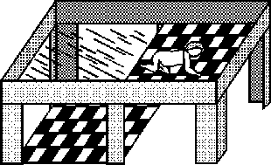
We are all capable of estimating depth accurately, at least in our immediate surroundings. If we couldn't, we'd have some difficulty picking food up and putting it in our mouths.
Gibson and Walk's classic 'visual cliff' experiment of 1960 makes it clear that very young babies can perceive depth.
The child is placed on the raised area on a sheet of glass which covers the black and white squares. On one half of the area, the black and white squares are not immediately below the glass, but about one meter below. Six-month old babies were very reluctant to crawl over the 'cliff' even when their mothers encouraged them to do so. Because a six-month old human may already have learnt depth perception, the experiment was tried with animals such as chicks, kids and lambs which can walk as soon as they are born. They too refused to cross the cliff.

Size constancy
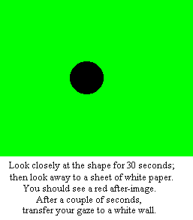
Try the exercise on the right.
You should have found that the size of the after-image varies in proportion to the distance from the eye. If the distance from the eye to the paper was 20 cm and the distance to the wall 100 cm, the after-image on the wall will be five times bigger than that on the paper.
We have referred to these functions as hard-wired. In fact, it is very difficult to know what functions of perception are innate, what mature after birth and what are learned. Of possibly more interest for Communication, Cultural and Media Studies are those which are learned - and that's what we'll take a look at in the following sections.

