Osgood & Schramm Circular Model
If you've already looked at the other models in this section on basic models of communication, you'll be aware that a criticism that could be made of some of them is that they present communication as a linear process, within which the rôles of sender and receiver are clearly distinguished.
Schramm stated:
In fact, it is misleading to think of the communication process as starting somewhere and ending somewhere. It is really endless. We are little switchboard centers handling and rerouting the great endless current of information....
(Schramm W. (1954) quoted in McQuail & Windahl (1981)
The Osgood and Schramm circular model is an attempt to remedy that deficiency: The model emphasizes the circular nature of communication. The participants swap between the rôles of source/encoder and receiver/decoder.
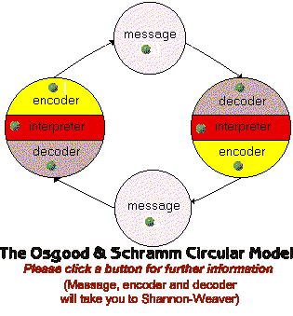

Osgood & Schramm: Interpreting
The model is particularly helpful in reminding us of the process of interpretation which takes place whenever a message is decoded.
The more mechanical models, particularly those concerned primarily with machine communication, tend to suggest that fidelity will be high as long as physical noise is reduced to a minimum or strategies (such as increasing channel redundancy) are adopted to counter the noise. This circular model reminds us that receiving a message is not simply a matter of decoding, but also of interpreting the message.
Whenever we receive data from the world around us, even in, say, the apparently very simple act of seeing what's in front of us, we are engaged in an active process of interpretation, not simply taking in information, but actively making sense of it. An important question is: what criteria are we using to make sense of what we are receiving? Since the criteria we use will inevitably differ from one person to another, there will always be semantic noise. If we can answer that question about our audience, then we stand a chance of communicating successfully.
But it's certainly not an easy question to answer, as you will see if you take a look at Berlo's SMCR Model, which is one of the most useful models as a starting point for organizing any practical work in communication.

