Attitudes

Components of attitudes
It is generally accepted that attitudes are composed of
 | affective (feelings) component | 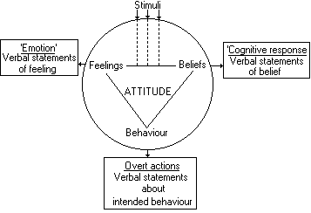
 | cognitive (beliefs) component
 | behavioural (actual actions) component

as shown graphically above (from Spooncer (1992)). Similarly, Baron and Byrne define attitudes as relatively lasting clusters of feelings, beliefs, and behaviour tendencies directed towards specific persons, ideas, objects or groups (1984: 126)
The fact that there are these components makes the notion of an attitude somewhat slippery, to say the least. Some beliefs certainly don't seem to involve attitudes. I believe that Timbuktu is in the Sahara desert, but I don't particularly think that's a jolly good thing or a dreadful shame. On the other hand, a belief in God will entail a range of attitudes. In that case, beliefs shape attitudes. It could work the other way round: a negative attitude towards, say, women could lead one readily to believe that most of them are bad drivers.
It is that interaction between beliefs and attitudes, as well as the interaction with whatever underlying values we may hold and opinions we may express that makes attitudes difficult to get a hold on. And, of course, we can't directly observe them - we can only ask people or infer their attitudes from what they do.

Measuring Attitudes
You will very probably need to assess people's attitudes during your practical work, either because your project is intended to change people's attitudes or because you need to gain some measure of their appreciation of your finished artefact. You will probably find it useful to look at some of the sections listed below, which are concerned with attitude measurement.

